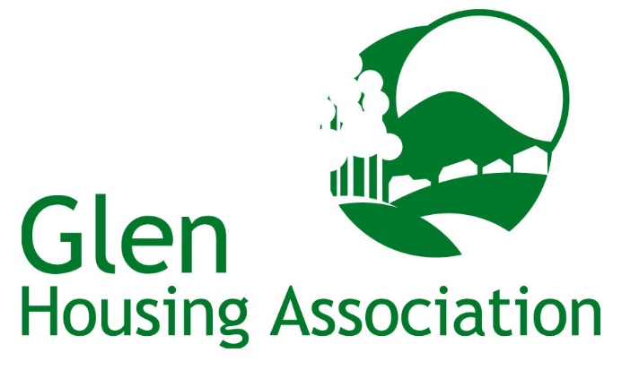

Employee/Governing Body Member Fair Processing Notice

(How we use employee information)

This Notice explains what information we collect, when we collect it and how we use this. During the course of our activities we will process personal data (which may be held on paper, electronically, or otherwise) about you and we recognise the need to treat it in an appropriate and lawful manner. The purpose of this notice is to make you aware of how we will handle your information.

- Glen Housing Association (“we” or “us”) is committed to a policy of protecting the rights of individuals with respect to the processing of their personal data and adhere to guidelines published in the [Data Protection Act of 2018] (the 2018 Act) and the General Data Protection Regulation (EU) 2016/679 (GDPR), together with any domestic laws subsequently enacted. We collect and use personal data for a variety of reasons.

We are registered as a Data Controller with the Office of the Information Commissioner (ICO) under registration number Z5641313 and we are the data controller of any personal data that you provide to us.

Our Data Protection Officer (DPO) is Calum Kippen, Kingdom Group, Saltire Centre, Pentland Court, Glenrothes, Fife KY6 2DA Tel: 01592 631661. Any questions relating to this notice and our privacy practices should be sent to him at the above address or by email to: calumkippen@kha.scot

- We collect the following information from you through a variety of resources (i) directly from you; or (ii) third parties (including employment agencies, pensions services):

- Name
- Date of Birth
- Address
- Telephone Number
- E-mail address
- NI number
- Personal characteristics such as gender and ethnic group
- Qualifications
- Absence information
- Next of Kin details
- Health Issues/Allergies

We collect and use the above information and personal data for:

  - Administration of contracts of employment
  - Payment of salaries
  - Recruitment and selection
  - Pensions and associated benefits, appraisal, training and development
  - Membership of professional bodies
  - Personal welfare/Health & Safety
  - Regulatory statistical reporting

- We may disclose to and share information about you with third parties for the purposes set out in this notice, or for purposes approved by you, including the following:

- To process your monthly salary payments;
- To allow your pension provider to process pensions information and handle your pension;
- If we enter into a joint venture with or are merged with another business entity, your information may be disclosed to our new business partners.

- Your information will only be stored within the UK and EEA.

- When you give us information we take steps to make sure that your personal information is kept secure and safe.

5.1 Paper Storage
Where Personal Data is stored on paper it will be kept in a secure place where unauthorised personnel cannot access it. When the Personal Data is no longer required, it will be disposed of, in a manner ensuring its secure destruction. If the Personal Data requires to be retained on a physical file then it will be stored in accordance with the Association’s retention provisions.

5.2 Electronic Storage
Personal Data stored electronically will be protected from unauthorised use and access. Personal Data will be password protected when being sent internally or externally to the Association’s data processors or those with whom the Association has entered in to a Data Sharing Agreement. If Personal Data is stored on removable media then that removable media must be encrypted and stored securely at all times when not being used. If Personal Data is stored on mobile devices, these devices will be password protected at all times.

- We review our data retention periods regularly and will only hold your personal data for as long as is necessary for the relevant activity, or as required by law (we may be legally required to hold some types of information), or as set out in any relevant contract we have with you.

Data retention guidelines on the information we hold is provided in our Document Retention and Disposals Policy (Appendix 4 of the Privacy Policy).

- You have the right at any time to:

- ask for a copy of the information about you held by us in our records; and
- ask us to correct any inaccuracies of fact in your information
- request that we restrict your data processing
- data portability
- rights related to automated decision making including profiling
- make a request to us to delete what personal data of yours we hold and;
- object to receiving any marketing communications from us

These rights are qualified and are not absolute.

- If you would like to find out more about how we use your personal data or want to see a copy of information about you that we hold, or wish to exercise any of your above rights, please make such a request to our DPO, Calum Kippen, Kingdom Group, Saltire Centre, Pentland Court, Glenrothes, Fife KY6 2DA Tel: 01592 631661 or by email to: calumkippen@kha.scot

If you have any complaints about the way your data is processed or handled by us, please contact our DPO. If you remain unsatisfied after your complaint has been processed by us, you also have the right to complain to the Information Commissioner’s Office in relation to our use of your information. They can be contacted as follows:
The Information Commissioner’s Office – Scotland
45 Melville Street, Edinburgh, EH3 7HL
Telephone: 0303 123 1115
Email: Scotland@ico.org.uk

The accuracy of your information is important to us – please help us keep our records updated by informing us of any changes to your personal and contact details.

