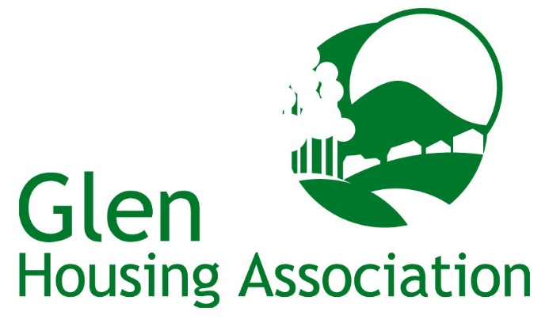

GENERAL DATA PROTECTION REGULATIONS
Fair Processing Notice
(How we use your personal information)

This notice explains what information we collect, when we collect it and how we use this. During the course of our activities we will process personal data (which may be held on paper, electronically, or otherwise) about you and we recognise the need to treat it in an appropriate and lawful manner. The purpose of this notice is to make you aware of how we will handle your information.

Who are we?

Glen Housing Association, a Scottish Charity (Scottish Charity Number SC031874), a registered society under the Co-operative and Community Benefit Societies Act 2014 with Registered Number HAL267 and having their Registered Office at 28 Heimdal Gardens, Glenrothes, Fife KY7 6TZ (“we” or “us”) take the issue of security and data protection very seriously and strictly adhere to guidelines published in the [Data Protection Act of 2018] (the 2018 Act) and the General Data Protection Regulation (EU) 2016/679 (GDPR) which is applicable from the 25th May 2018, together with any domestic laws subsequently enacted.

We are registered as a Data Controller with the Office of the Information Commissioner (ICO) under registration number Z5641313 and we are the data controller of any personal data that you provide to us.
Our Data Protection Officer (DPO) is Calum Kippen, Kingdom Group, Saltire Centre, Pentland Court, Glenrothes, Fife KY6 2DA Tel: 01592 631661.

Any questions relating to this notice and our privacy practices should be made to:
The Corporate Manager, Glen Housing Association, 28 Heimdal Gardens, Glenrothes, Fife KY7 6TZ, Tel No: 01592 621188 or info@glenhousing.co.uk

We collect information about you to enable us to perform our contractual obligations. You, in turn, are under a contractual obligation to provide the data requested from you to enable performance of the contract (i.e. the tenancy agreement you are party to):

- when you apply for housing with us, become a tenant, request services/ repairs, or otherwise provide us with your personal details
- when you apply to become a member;
- from your use of our online services, whether to report any tenancy related issues, make a complaint, enquire about applying for a house, or otherwise;
- from your arrangements to make payment to us (such as bank details, payment card numbers, employment details, benefit entitlement and any other income and expenditure related information);

Under the terms of the Tenancy Agreement, you may be required to provide us with some of the following information:
- Name;
- Address;
- Telephone Number
- E-mail Address (if applicable);
- National Insurance Number;
- Tax Code
- Next of Kin;
- Keyholder Information;
- Date of Birth;
- Support Needs (if any);
- Medical/Health Issues;
- Vulnerabilities/Risks
- Employment Status;
- Proof of ID;
- Bank Details, Credit/Debit Card Details;
- Criminal Convictions/Offences
- Ethnicity/Nationality;
- Language;
- Housing Benefit Notifications;
- Images

We may receive the following information from third parties:
- Benefits information, including awards of Housing Benefit/ Universal Credit
- Payments made by you to us;
- Complaints or other communications regarding behaviour or other alleged breaches of the terms of your contract with us, including information obtained from Police Scotland;
- Reports as to the conduct or condition of your tenancy, including references from previous tenancies, and complaints of anti-social behaviour

Why we need this information about you and how it will be used

We need your information and will use your information to undertake and perform our obligations and duties to you in accordance with the terms of our contract with you. This includes:

- to enable us to supply you with the services and information which you have requested and meet your specific needs;
- to enable us to respond to your repair request, housing application and complaints made;
- to analyse the information we collect so that we can administer, support and improve and develop our business and the services we offer;
- to contact you in order to send you details of any changes to our services or supplies which may affect you;
- for all other purposes consistent with the proper performance of our operations and business; and
- to contact you for your views on our services.

Sharing of Your Information

The information you provide to us will be treated by us as confidential and will be processed only by our employees within the UK/EEA. We may disclose relevant information to other third parties who act for us for the purposes set out in this notice or for purposes approved by you, including the following:

- If we enter into a joint venture with or merge with another business entity, your information may be disclosed to our new business partners;
- If we instruct repair or maintenance works, your information may be disclosed to any contractor/consultant;
- If we are investigating a complaint, information may be disclosed to Police Scotland, Local Authority departments, Scottish Fire & Rescue Service and others involved in any complaint, whether investigating the complaint or otherwise;
- If we are updating tenancy details, your information may be disclosed to third parties (such as utility companies and the Local Authority);
- If we are investigating payments made or otherwise, your information may be disclosed to payment processors, Local Authority and the Department for Work & Pensions;
- If we are conducting a survey of our services, your information may be disclosed to third parties assisting in the compilation and analysis of the survey results;
- The production of publicity material for electronic distribution via our website or in hard copy format e.g. Newsletters, Annual Reports, Leaflets;
- If we have to take legal action against your tenancy or pursue you for tenancy related debt, your information will be disclosed to Sheriff Officers and/or Solicitors;
- If we feel that you would benefit from support or advisory services we would disclose your information to relevant agencies e.g. Mediation, Interpretation Services;
- For the purposes of crime prevention and/or the protection of vulnerable adults/children we would disclose your information to Police Scotland, Health & Social Care Services, Victim Support, Local Authority etc.

Unless we have a lawful basis for disclosure, we will not otherwise share, sell or distribute any of the information you provide to us without your consent.

Your information will only be stored within the UK and EEA.

Security

When you give us information we take appropriate steps to ensure that your personal information is kept secure and safe and that no unauthorised personnel can access it (as per our Privacy Policy and our IT Security Policy).

How long we will keep your information

We review our data retention periods regularly and will only hold your personal data for as long as is necessary for the relevant activity, or as required by law (we may be legally required to hold some types of information), or as set out in any relevant contract we have with you. Your data will be destroyed after the retention period has passed if it is no longer required for the reasons it was obtained.

The full data retention schedule is detailed within our Document Retention and Disposals Policy which is available, free of charge from our office or from our website: www.glenhousing.co.uk .

Your Rights

You have the right at any time to:

- ask for a copy of the information about you held by us in our records;
- ask us to correct any inaccuracies of fact in your information;
- request that we restrict your data processing;
- data portability;
- rights related to automated decision making including profiling;
- make a request to us to delete what personal data of yours we hold; and
- object to receiving any marketing communications from us.

If you would like to exercise any of your rights above, please contact our DPO, Calum Kippen by email: calumkippen@kha.scot or telephone: 01592 631661. You should note that your rights under the GDPR and the 2018 Act are not absolute and are subject to qualification.

If you have any complaints about the way your data is processed or handled by us, please contact our DPO, Calum Kippen by email: calumkippen@kha.scot or telephone: 01592 631661.. If you remain unsatisfied after your complaint has been processed by us, you also have the right to complain to the Information Commissioner’s Office in relation to our use of your information. They can be contacted as follows:

The Information Commissioner’s Office – Scotland
45 Melville Street, Edinburgh, EH3 7HL
Telephone: 0303 123 1115
Email: Scotland@ico.org.uk

The accuracy of your information is important to us - please help us keep our records updated by informing us of any changes to your email address and other contact details.

